

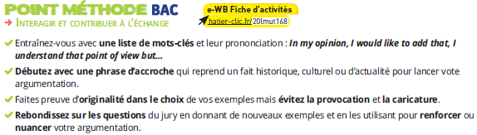

**BAC prep! Explain which document best illustrates “Scientific innovations and responsibility” in your opinion.**

Aide : Relisez toutes les questions qui ont été posées sur les documents vus en classe afin de mieux cerner la consigne et d’y répondre parfaitement.

|  |  |
| --- | --- |
| If you choose the poster | If you choose the quote |
| List the vocabulary that will be useful for your presentation | |
|  |  |
| Find a great way to start your presentation | |
|  | |
| Answer the questions with new examples | |
|  | |