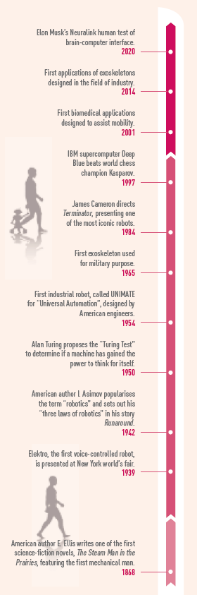
1. Read the time line on the right. Highligh the elements related to fictional robots.

2. Watch the video without the sound and focus on the different types of images. Complete the first line of the chart.
Then complete the second line of the chart with examples from the time line.

Type of images | ………………………. | ……………………….
Examples | ……………………….  ……………………….  ……………………….  ……………………….  ……………………….  ……………………….  ……………………….  ……………………….  ……………………….  ……………………….  ……………………….  ……………………….  ……………………….  ……………………….  ……………………….  ……………………….  ………………………. | ……………………….  ……………………….  ……………………….  ……………………….  ……………………….  ……………………….  ……………………….  ……………………….  ……………………….  ……………………….  ……………………….  ……………………….  ……………………….  ……………………….  ……………………….  ……………………….  ……………………….

3. Watch the video with the sound and take notes. Complete the grid with other examples. Add the date when mentioned.

4. What type of vision of the robots does each type of images convey? Explain why. Illustrate with examples.
……………………….……………………….……………………….
……………………….……………………….……………………….
……………………….……………………….……………………….
……………………….……………………….……………………….

5. Complete the time line with new elements taken from the video or from your the chart above. Use it to comment on the different stages of the evolution of robots.
……………………….……………………………................………….……………………….
……………………….……………………………................………….……………………….
……………………….……………………………................………….……………………….

6. Read Let’s focus on… Alan Turing page 42 and present the Turing test.
……………………….……………………………................………….……………………….
……………………….……………………………................………….……………………….
……………………….……………………………................………….……………………….

7. Imagine four questions for the Turing test.
……………………….……………………………................………….……………………….
……………………….……………………………................………….……………………….
……………………….……………………………................………….……………………….
……………………….……………………………................………….……………………….

