

**1.** Watch this 60-second video narrated by American actor Forest Whitaker. Give your first impressions and say what type of video it is. Look at the caption.

**2.** Watch the video again with the sound off. Write a caption under each screenshot.

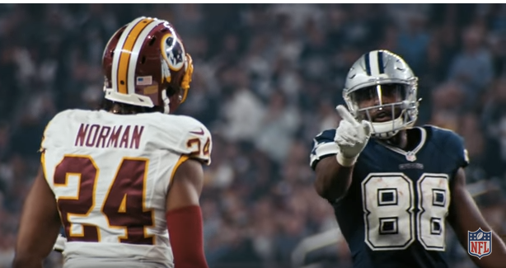

❷

❶



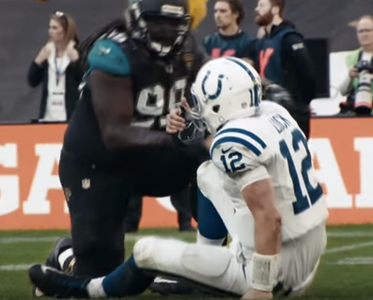

❸

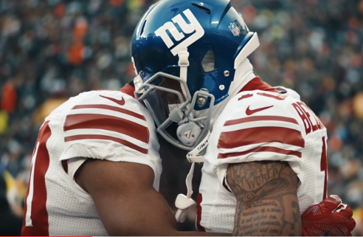

❹

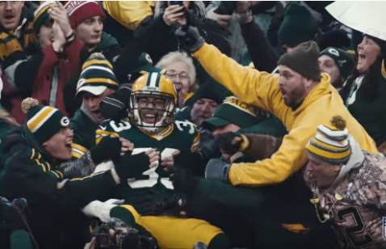

**❺**

**3.** Now watch the video again with the sound and put the sentences in the correct order.

Inside these lines it can bring out the best in each other and live united. Inside these lines.

Inside these lines we may have our differences but recognize there’s more that unites us.

Inside these lines we don’t have to come from the same place to help each other reach the same

destination. “No time to waste, let’s work.”

Inside these lines it’s a game of inches. “Touchdown”. And there’s no such thing as an easy yard when

you’re fighting to move forward.

Inside these lines we’re not only defined by our victories but by the way we handle our defeats.

**4.** Complete the summary using these words: stronger – power – unifying – together.

For Super Bowl LI, the NFL decided to demonstrate the of football to bring people

, to show the power of the game. The roof of this concept

was that together we are , and it is our diversity that makes that so.