

**1.** Look at the image and guess what the video could be about.

**2.** Watch the video once. Match the names of the historical figures with the dollar bills they appear on. Be careful, the video does not mention all of them!

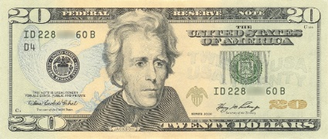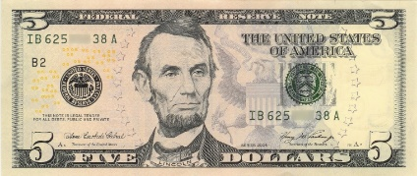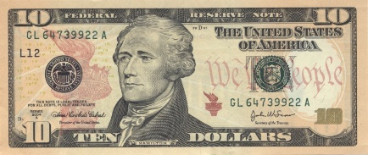

○

○

○

|  |
| --- |
| John F. Kennedy ○  Harriet Tubman ○  Martin Luther King, Jr. ○  Alexander Hamilton ○  Suffragists ○  Andrew Jackson ○ |

**3.** Find the common points between the historical figures on American bills.

**4.** Associate as many names and words as you can to the $5, $10 and $20 bills. Explain why Harriet Tubman is not on the $10 bill.

**5.** Watch the video again: listen to a few people’s reactions to the news. Use at least one of the following adjectives in a sentence to describe their reactions: furious – happy – proud – upset – indifferent.